Html code-
<html>
<head>
<title>Student Information Desk</title>
<link rel = "stylesheet" href = "lab1(css).css">
</head>
<body>
<h1>Student Information</h1>
<form>
<div>
<label for = "name">Student Name:</label>
<input type = "text" id = "name" required>
</div>
<div>
<label for = "password">Password:</label>
<input type = "password" id = "password" required>
</div>
<div>
<label for = "email">E-mail:</label>
<input type = "email" id = "email">
</div>
<div>
<label for = "dob">Date of Birth:</label>
<input type = "date" id = "dob">
</div>
</div>
<label for = "age">Age:</label>
<input type = "number" id = "age">
<div>
<label for = "cgpa">CGPA:</label>
<input type = "text" id = "cgpa">
</div>
<div>
<label for = "status">Student Status:</label>
<input type = "radio" name = "status" value = "Valid" checked>Valid
<input type = "radio" name = "status" value = "Invalid">Invalid
</div>
<div>
<label for = "interest">Area of Interest:</label>
<input type = "checkbox" name = "interest" value = "CP">CP
<input type = "checkbox" name = "interest" value = "r&d">R&D
<input type = "checkbox" name = "interest" value = "swd">Software Development
<input type = "checkbox" name = "interest" value = "AI&ML">AI/ML
</div>
<div>
<label for = "grade">Grade:</label>
<select name = "grade">
<option value = "A+">A+</option>
<option value = "A">A</option>
<option value = "B+">B+</option>
<option value = "B">B</option>
<option value = "C+">C+</option>
<option value = "C">C</option>
<option value = "D+">D+</option>
<option value = "D">D</option>
<option value = "F">F</option>
</select>
</div>
<div>
<input type = "submit" value = "Submit Information">
</div>
</form><hr style = "border: 1px solid black;">
</body>
</html>
CSS code-
body {
font-family: Arial, sans-serif;
margin: 20px;
padding: 20px;
background-color: lightblue;
}
h1 {
color:navy;
text-align: center;
text-decoration: underline;
}
form {
width: 600px;
margin: auto;
border: 2px solid black;
padding: 30px;
background-color: white;
border-radius: 30px;
}
label {
font-weight: bold;
color: black;
margin-bottom: 20px;
display: inline-block;
}
input, select, textarea {
margin-left: 20px;
padding: 5px;
border-radius: 10px;
}
input[type = "submit"]{
background-color: green;
color: white;
border: none;
padding: 8px 15px;
cursor: pointer;
}
input[type = "submit"]:hover{
background-color: darkgreen;
}
HTML/CSS output-
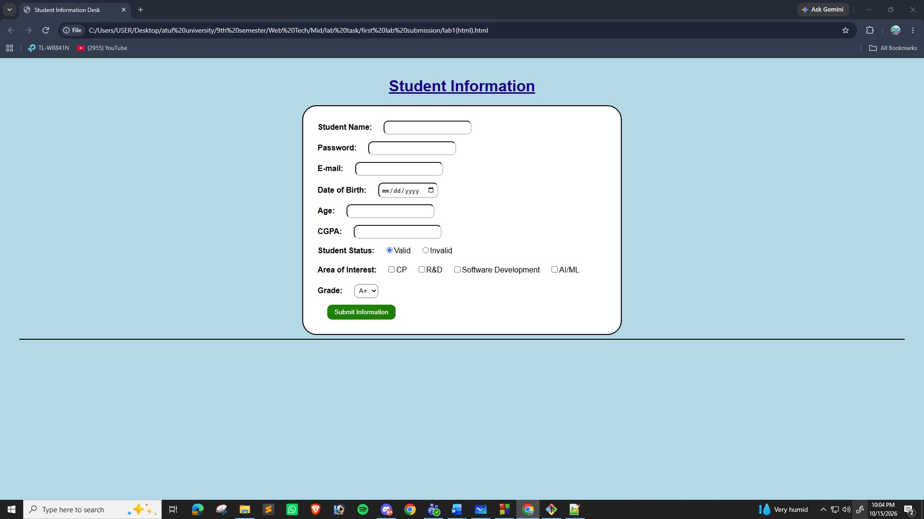
JS code-
let name = prompt("Enter student name:");
let age = Number(prompt("Enter student age:"));
let cgpa = Number(prompt("Enter student CGPA:"));
let status = prompt("Enter student status:");
let grade = prompt("Enter student grade:");

console.log("");
console.log("Student Information:");
console.log("Name:", name);
console.log("Age:", age);
console.log("CGPA:", cgpa);
console.log("Status:", status);
console.log("Grade:", grade);
console.log("");
let courses = ["Web Technology", "OOP", "Database"];

console.log("Course Names:");

for (let i = 0; i < courses.length; i++) {
console.log(courses[i]);
}
console.log("");

let marks = Number(prompt("Enter student marks:"));
let result;
console.log("");
if (marks >= 80) {
result = "A+";
}
else if (marks >= 70) {
result = "A";
}
else if (marks >= 60) {
result = "B";
}
else {
result = "F";
}
console.log("Marks:", marks);
console.log("Calculated Grade:", result);
function showStudent(name, age) {
console.log("Student Name:", name);
console.log("Student Age:", age);
}

showStudent(name, age);
console.log("");
let students = [];

for (let i = 0; i < 3; i++) {
students[i] = prompt("Enter student name " + (i + 1) + ":");
}

console.log("");
console.log("All Student Names:");

for (let i = 0; i < students.length; i++) {
console.log(students[i]);
}
JS Code Screenshot(Online Compiler)-
